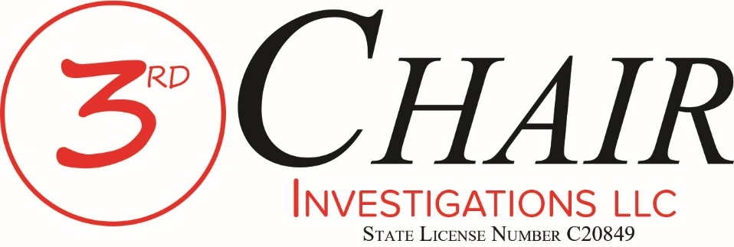
Thank you for considering Third Chair Investigations LLC. We stand ready to assist you and your clients.

Once the appointment order is signed, we need a certified copy of the order to get started.
- Please either e-mail us the order to Appointments@ThirdChair.com or fax the order to 817-554-1534.
- For cases that are on TechShare, please add Bianca Hadley, Bianca@ThirdChair.com to the case as a participant. Bianca will build the case file for the Investigator in our records management system.

Once we receive the appointment order, you will receive back an e-mail acknowledging that along with an e-mail letting you know who the lead Investigator will be from 3rd Chair.

Should you ever have any questions, please do not hesitate to contact us.

Third Chair Investigations LLC
State License No. C20849
2502 Gravel Drive
Fort Worth, Texas 76118
817-953-3385
817-554-1534 fax
Documents filed under seal are excluded from Electronic Submission. Rule 1.3(1) - Tex. Crim. App. Misc. Order 17-005
Click to view the rules......

No. _________________
THE STATE OF TEXAS | § | IN THE _____ JUDICIAL
 | §
VS. | § | DISTRICT COURT OF
 | §
____________________________ | § | DENTON COUNTY, TEXAS

DEFENDANT’S EX PARTE MOTION FOR APPROVAL OF FUNDS FOR COURT-APPOINTED INVESTIGATOR
Filed Under Seal

TO THE HONORABLE JUDGE OF SAID COURT:

COMES NOW, the Defendant in the above-styled and numbered cause, by and through his attorney of record, ____________________, and files this Motion for Approval of Funds for Court-Appointed Investigator; and in support thereof would show this Honorable Court as follows:
I.
In the instant case, the Defendant is charged with felony offenses. The Defendant has been found to be indigent. The Defendant remains indigent. Undersigned counsel was court-appointed to represent the Defendant on _____________________, 201___.
II.
Counsel’s review of the facts of the instant case reveals that it is necessary to the defense of the case to investigate the facts of the case and the witnesses thereto. Counsel requests that the Court appoint Third Chair Investigations LLC, Texas License No. C20849 to perform investigative services in this case. Counsel anticipates that investigative fees will be less than $___________. Counsel therefore requests that the Court approve payment not to exceed this amount when the investigator has rendered service.
III.
A compelling need exists in this case for the assistance of an investigator to address a significant issue for trial. The Defendant will be irreparably harmed if he is unable to perform a proper investigation in the preparation of this case for trial in that his side of the issues may not be otherwise properly developed and presented.
WHEREFORE, PREMISES CONSIDERED, the Defendant hereby requests that the Court grant an ex parte hearing on this Motion in the instant cause; and that subsequent to the hearing of said Motion that the Court ORDER the approval of funds for an investigator to assist the Defendant in the preparation and trial of this case.

Respectfully submitted,

____________________________

S.B.O.T. No.

ATTORNEY FOR DEFENDANT

FIAT
IT IS HEREBY ORDERED that the above Motion be heard on the ______ day of ________________, 20___, at ________________ o’clock ___m.
____________________________
JUDGE PRESIDING

CERTIFICATE OF SERVICE
I hereby certify that no copy of this Motion was delivered to the Denton County Criminal District Attorney’s Office, attorneys for the State of Texas, because Defense Counsel wishes to proceed ex parte on said Motion.

______________________________
ATTORNEY FOR DEFENDANT

No. _________________
THE STATE OF TEXAS | § | IN THE _____ JUDICIAL
 | §
VS. | § | DISTRICT COURT OF
 | §
____________________________ | § | DENTON COUNTY, TEXAS

O R D E R
Filed Under Seal

The above and foregoing Defendant's Motion for Approval of Funds for Court-Appointed Investigator having been heard by the Court, and the Court having considered such Motion, it is hereby ordered that the Defendant's Motion be GRANTED and the Court hereby appoints THIRD CHAIR INVESTIGATIONS LLC, Texas License No. C20849.
The Court further orders that THIRD CHAIR INVESTIGATIONS LLC and its agents / investigators are authorized to visit and interview the above-named Defendant in the care custody and control of the Denton County Sheriff.
Matters learned by THIRD CHAIR INVESTIGATIONS LLC and its agents / investigators in the course of this investigation are privileged according to Texas Rules of Evidence 503 and shall not be disclosed without the express consent of the Defendant and their attorney(s) of record.
The Court further ORDERS that funds for the services of an investigator to assist the above-named Defendant in the preparation and trial of the instant case be approved in the amount
of $______________ at a labor rate of $75.00 per hour.
In addition, the Court ORDERS that this Motion and Order for an Investigator by the Defendant be kept by the District Clerk of Denton County, Texas under seal with the papers of the cause numbers listed above.

IT IS SO ORDERED.

SIGNED on this the _____ day of ________________, 201___

_____________________________
Third Chair Investigations LLC
Denton County Vendor: 21782
2502 Gravel Drive
Fort Worth, Texas 76118
817-953-3385
817-554-1534 fax
Orders@ThirdChair.com
JUDGE PRESIDING

