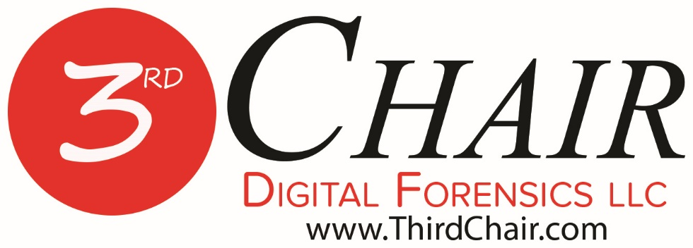
Documents filed under seal are excluded from Electronic Submission. Rule 1.3(1) - Tex. Crim. App. Misc. Order 17-005
Click to view the rules......

Third Chair Digital Forensics LLC
2502 Gravel Drive
Fort Worth, Texas 76118
817-953-3385
817-554-1534 fax
Thank you for considering Third Chair Digital Forensics LLC. We stand ready to assist you and your clients.

Once the order is signed, we need a certified copy of the order to set up the examination.

Please either e-mail us the order to Orders@ThirdChair.com or fax the order to 817-554-1534.

Should you ever have any questions, please do not hesitate to contact us.

No. _________________
THE STATE OF TEXAS | § | IN THE _____ JUDICIAL
 | §
VS. | § | DISTRICT COURT OF
 | §
____________________________ | § | ___________ COUNTY, TEXAS

AGREED MOTION FOR DEFENDANT’S ACCESS TO PHYSICAL EVIDENCE

TO THE HONORABLE JUDGE OF SAID COURT:
COMES NOW, the Defendant in the above-styled and numbered cause, by and through his attorney of record, __________________, and files this Agreed Motion for Defendant’s Access to Physical Evidence; and in support thereof would show this Honorable Court as follows:
I.
In the instant case, the Defendant is charged with or being investigated for a felony offense. Counsel for the Defendant has conferenced with the State’s Attorneys assigned to this case. The State’s Attorneys have agreed to allow the Defense expert access to the unencrypted forensic image of the “hard drives” and all of their contents that are the focus of this matter.
II.
At the time of the Defendant’s detention on this charge, peace officers of the _____________________________ took certain evidence from the Defendant, to wit: ______________________________________________. That evidence currently exists as forensic copies known as E01 files in the care custody and control of the _____________________________________________.
III.
The State and Defense both agree that under the Texas Code of Criminal Procedure article 39.14 a compelling need exists for the Defendant to perform his own forensic testing on the above-noted physical evidence in order to address a significant issue(s) at trial.
IV.
The Defendant has retained the services of THIRD CHAIR DIGITAL FORENSICS LLC to perform the necessary testing. In order for said law enforcement agency to allow access to the physical evidence in question to the Defendant for independent testing, a Court Order is necessary to clearly define what the law enforcement agency is to make available to THIRD CHAIR DIGITAL FORENSICS LLC.
WHEREFORE, PREMISES CONSIDERED, the Defendant hereby requests that the Court grant a hearing on this Motion in the instant cause; and that subsequent to the hearing on said Motion that the Court ORDER that the evidence in question be made available to THIRD CHAIR DIGITAL FORENSICS LLC in a manner that enables THIRD CHAIR DIGITAL FORENSICS LLC to conduct its examination using industry standard processing so that further forensic testing can be done for the preparation and trial of this case.

Respectfully submitted,

______________________________
ATTORNEY FOR DEFENDANT

FIAT
IT IS HEREBY ORDERED that the above Motion be heard on the ______ day of ________________, 201____, at ________________ o’clock ___m.

____________________________
JUDGE PRESIDING

CERTIFICATE OF SERVICE
I hereby certify that a copy of this Motion was delivered to the _________ County District Attorney’s Office, attorneys for the State of Texas.

______________________________
ATTORNEY FOR DEFENDANT

No. _________________
THE STATE OF TEXAS | § | IN THE _____ JUDICIAL
 | §
VS. | § | DISTRICT COURT OF
 | §
____________________________ | § | ___________ COUNTY, TEXAS

AGREED ORDER TO ALLOW DEFENSE TESTING OF EVIDENCE

The above and foregoing Defendant’s Agreed Motion For Access To Physical Evidence having been heard by the Court and the Court having considered such Motion, it is hereby ORDERED that the Motion be GRANTED.
IT IS THEREFORE, ORDERED, ADJUDGED, AND DECREED that the State of Texas must allow unencrypted access to the contents of the “hard drives” and /or electronic storage media collected and processed in this case to THIRD CHAIR DIGITAL FORENSICS LLC for testing at the discretion of Defendant. Any and all examination files, known as “E01” files shall be in an unencrypted format as well.
IT IS FURTHER ORDERED, ADJUDGED, AND DECREED that any testing of the evidence to be tested that the Defendant wishes to conduct will be completed within (period of time in which testing is ordered to be completed) of the date this ORDER is signed.

Signed this _______ of _________________, 20______.
__________________________________
Judge Presiding
Agreed AS to form:

_________________________
State’s Attorney

_________________________
Defense’s Attorney

